Kimberly Clarisse P. Puno
6AWEB – 2196
WD – 302 January 21, 2026
Midterm Lab Activity 4: Sharing Local Data Across Components
Screenshot of formatted output, typescript code and css, and reflection about the activity.
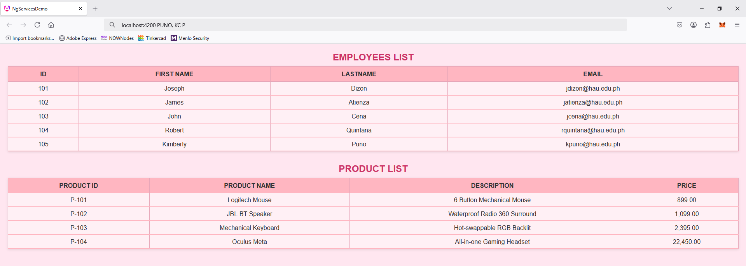
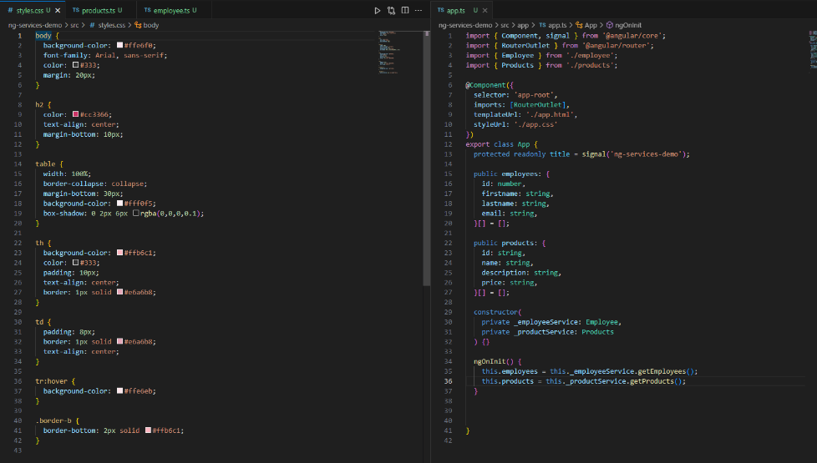

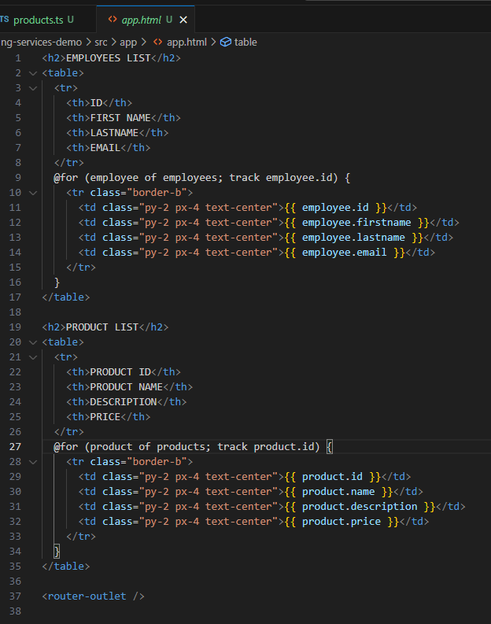

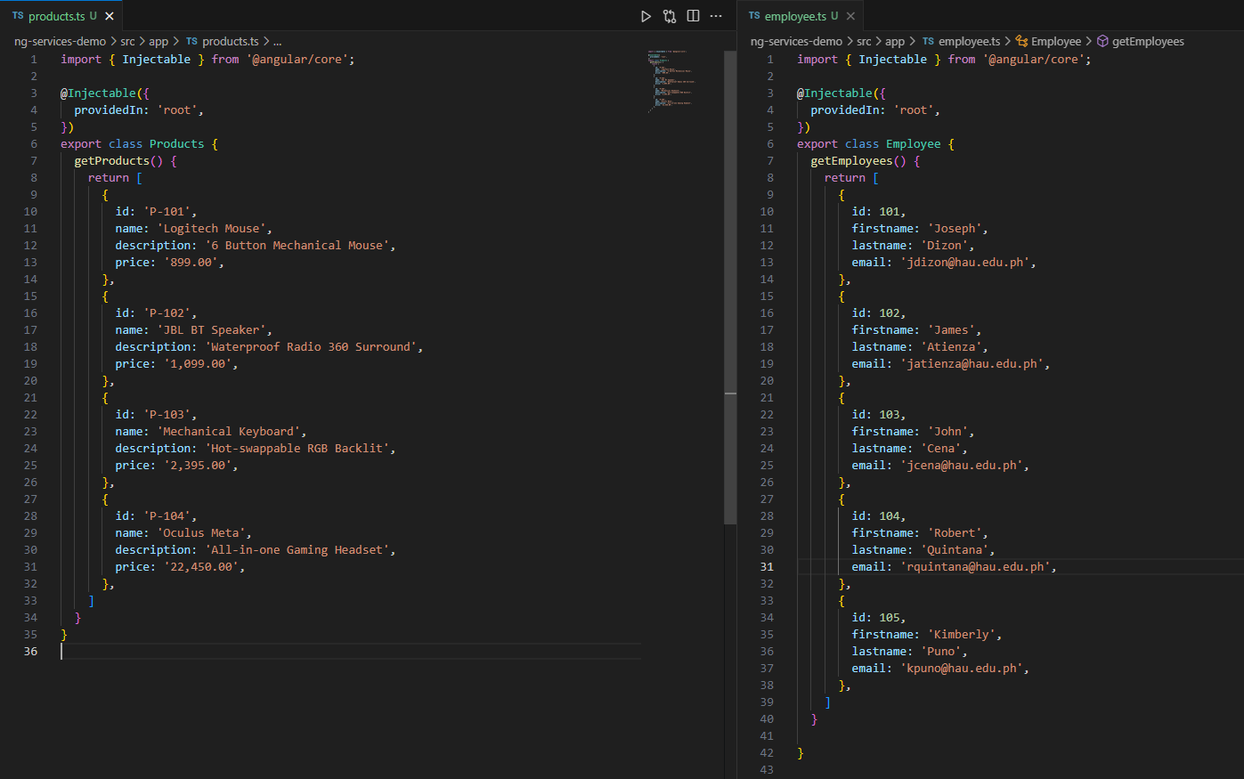

REFLECTION
This activity helped me understand how Angular services make it easier to share data across components. At first, the employee and product lists were only visible in one place, but using services allowed them to be reused anywhere in the app. I learned how dependency injection centralizes data management, which keeps the project organized and scalable. Overall, the task showed me the value of modular design and how services improve maintainability in Angular applications.

GITHUB LINK:
https://github.com/kmbrly-02/midterms.git

